WEEK 5: SYSTEM INTEGRATION AND PROTOTYPE PREPARATION

I. INTENDED LEARNING OUTCOME (ILO)
At the end of this laboratory activity, students should be able to:
Integrate completed system modules into a functional Alpha Version, conduct preliminary functionality checking, document integration results, and prepare professional prototype presentation materials for stakeholder evaluation.

II. PERFORMANCE TASK
By Week 5, the individual modules developed during Weeks 3 and 4 should be integrated into a single working system. Before presenting the prototype to stakeholders in Week 6, your team must verify module interactions, identify and resolve integration issues, and prepare prototype presentation materials.
The resulting Alpha Version should demonstrate the major functionalities of the system and provide evidence that the project is progressing toward deployment readiness.

III. WEEK 5 ACTIVITIES
Activity 1 – Module Integration Planning
Activity 2 – Full System Integration
Activity 3 – Preliminary Functionality Checking
Activity 4 – Alpha Version Validation
Activity 5 – Prototype Presentation Preparation
Activity 6 – System Integration Documentation
Activity 7 – Adviser Validation

ACTIVITY 1
MODULE INTEGRATION PLANNING

Purpose
To identify all modules that will be combined into the Alpha Version and verify their readiness for integration.
Procedure
- Review all completed modules from Weeks 3 and 4.
- Verify module completion status.
- Identify dependencies among modules.
- Establish integration sequence.
- Complete Form 1.

FORM 1
MODULE INTEGRATION PLAN
Directions
List all modules to be integrated into the Alpha Version.
Module | Completion Status | Dependency | Integration Sequence
Database Module (SQLite, 7 tables) | Complete | None — foundation layer | 1
Authentication Module | Complete | Database Module | 2
Packet Capture Module (Scapy + Npcap) | Complete | Network interface and Npcap driver | 3
Device Registry and Liveness Prober | Complete | Packet Capture Module, Database Module | 4
Threat Detection Engine | Complete | Packet Capture Module, Device Registry | 5
Notification Module (Socket.IO alerts) | Complete | Threat Detection Engine | 6
Administrator Dashboard (user interface) | Complete | Authentication Module, REST API, Notification Module | 7
Public Status Page | Complete | Threat Detection Engine, Database Module | 8
Reporting Module | Complete | Database Module | 9
Integration Readiness Checklist
☑ Database Ready
☑ Authentication Ready
☑ Core Functionalities Ready
☑ User Interfaces Ready
☑ Repository Updated

Prepared by: Bueno, Jannces G.
Group Leader
ACTIVITY 2
FULL SYSTEM INTEGRATION

Purpose
To combine all completed modules into a single working system.
Procedure
- Integrate front-end modules.
- Integrate back-end services.
- Connect database operations.
- Verify communication among modules.
- Complete Form 2.

FORM 2
SYSTEM INTEGRATION CHECKLIST
Directions
Component | Status | Remarks
User Interface Modules | Integrated | Dashboard, device table, threat log, connection log, settings and the public status page all call the REST API and receive live updates over Socket.IO.
Authentication Module | Integrated | Login, logout, session control and password change are wired to the admins table; every action is written to the administrator log.
Database Module | Integrated | All modules read and write through one thread-safe SQLite layer with serialised writes and WAL journaling.
Reporting Module | Integrated | Four report types export as CSV or PDF, and each export is recorded back into the reports table.
Notification Module | Integrated | Detected threats are pushed to the dashboard through Socket.IO with an audible alarm and colour-flash indicator.
Integration Verification
Verification Item | Result
Data Flow Verified | Pass
Module Communication Verified | Pass
Database Transactions Verified | Pass
User Access Verified | Pass
Required Evidence
☑ Integration Screenshots
☑ Running System Screenshot
☑ Repository Commit Evidence
Integration Screenshot
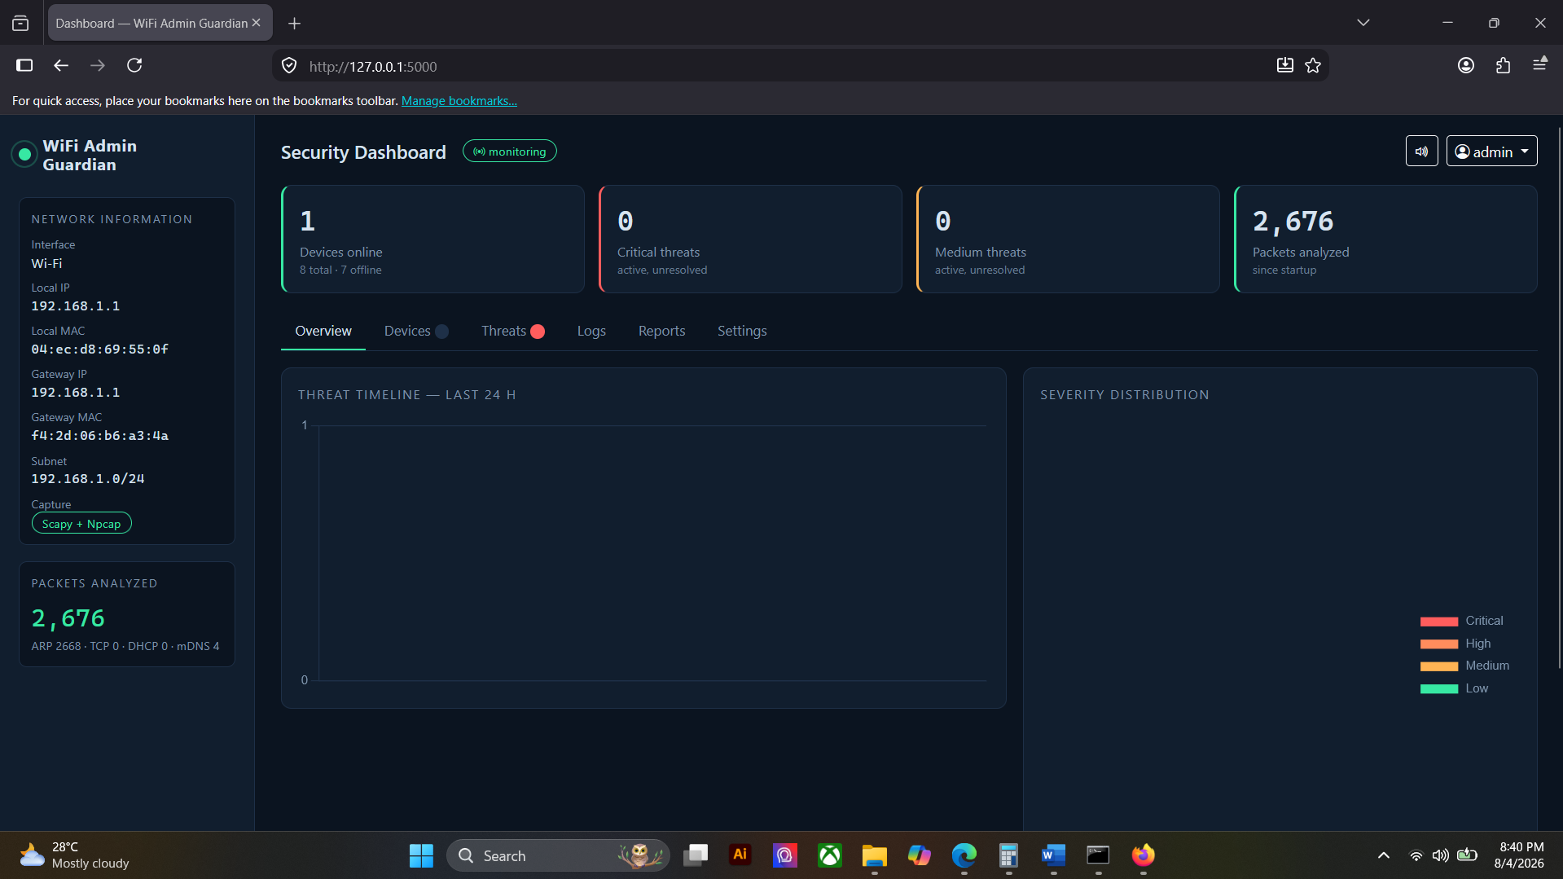

Running System Screenshot
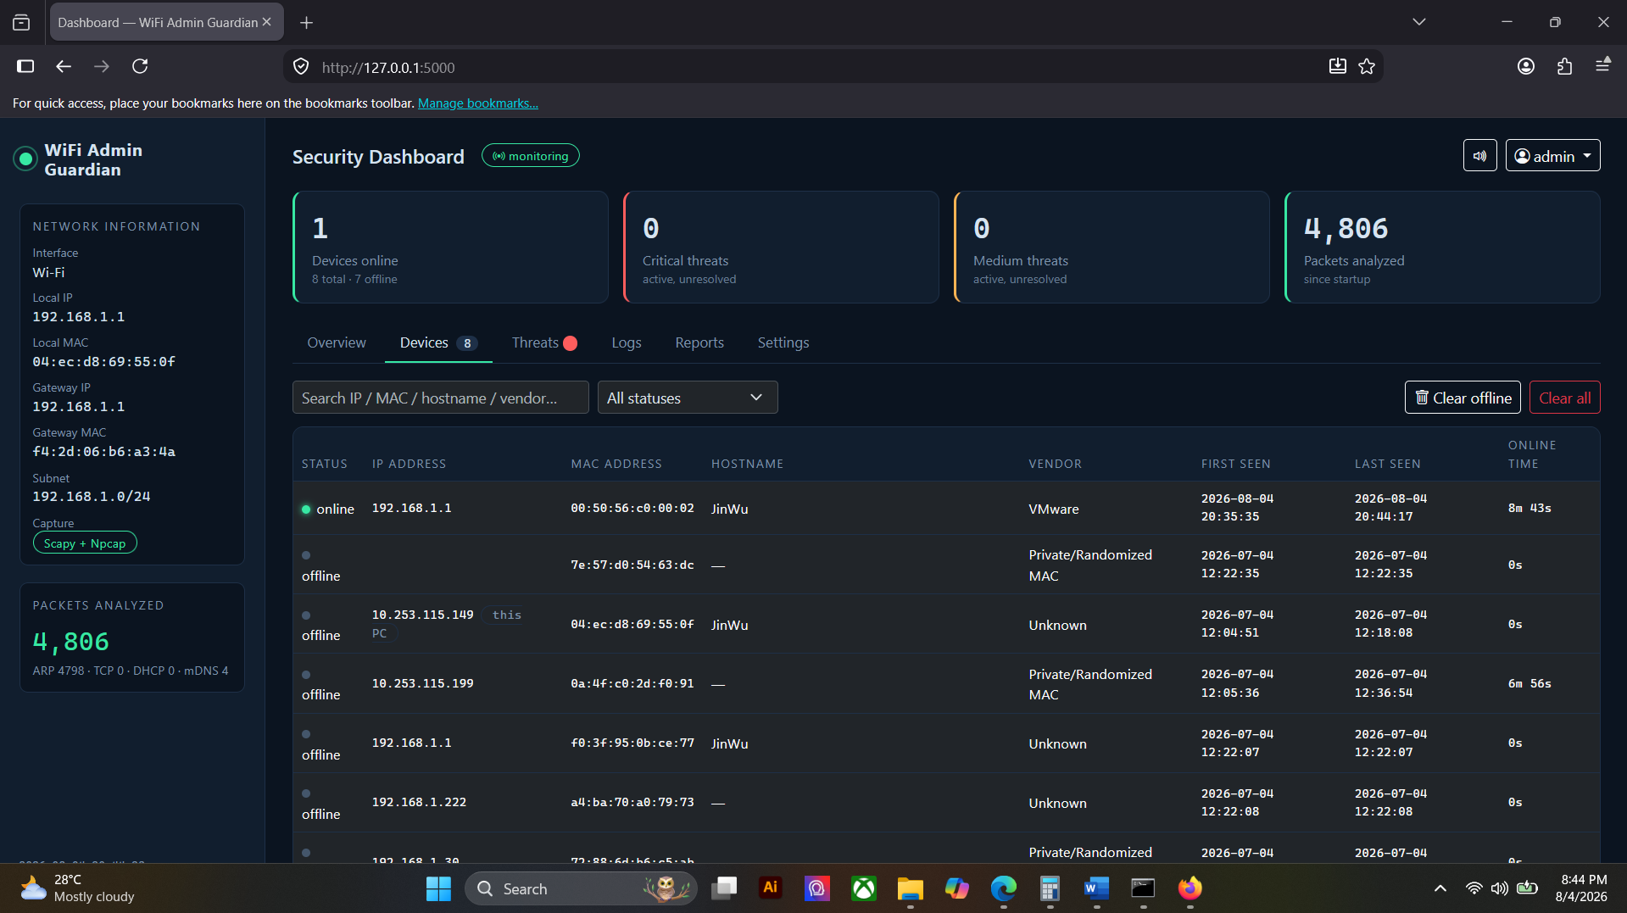
Repository Commit Evidence
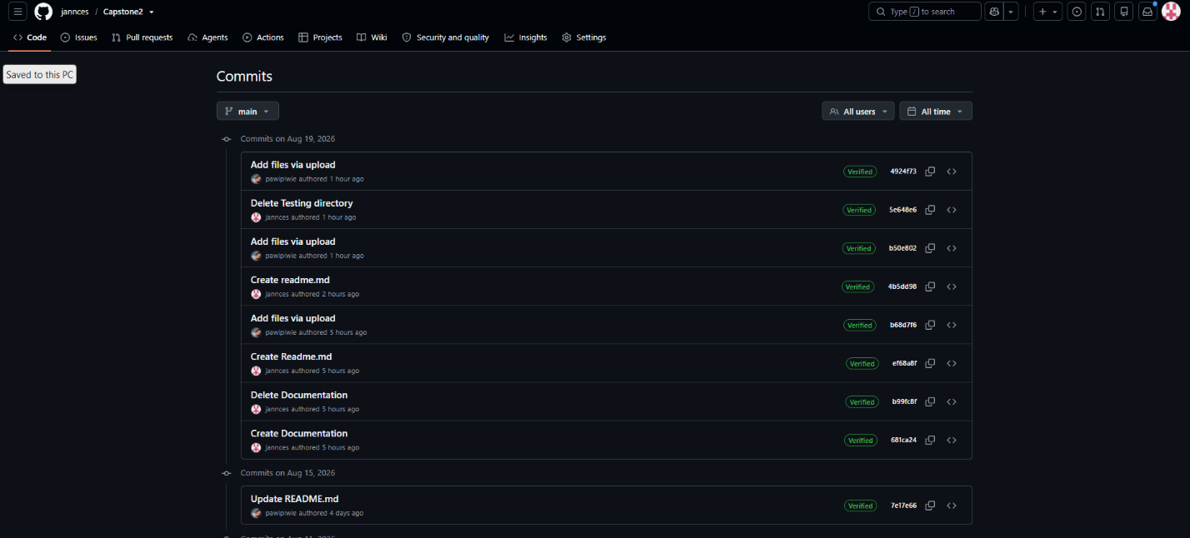

ACTIVITY 3
PRELIMINARY FUNCTIONALITY CHECKING

Purpose
To verify that major system functions operate correctly before prototype presentation.
Procedure
- Execute major user transactions.
- Verify expected outputs.
- Identify integration errors.
- Record corrective actions.
- Complete Form 3.

FORM 3
PRELIMINARY FUNCTIONALITY TEST REPORT

Directions
Functionality | Expected Result | Actual Result | Status
User Login | Valid credentials open the dashboard; invalid credentials are rejected and recorded. | Dashboard opened for valid credentials; invalid attempts rejected and written to the administrator log. | Pass
Data Entry | A device joining the network is registered automatically with its IP, MAC, hostname and vendor. | New devices appeared in the registry within seconds and were stored in the database. | Pass
Data Processing | Captured packets are inspected and a matching traffic pattern raises a classified threat. | Threats were raised with severity, evidence and mitigation text, then pushed to the dashboard live. | Pass
Data Retrieval | Device, threat, connection and administrator records are returned to the interface on request. | All record views loaded with correct and complete data. | Pass
Report Generation | A selected report exports as CSV or PDF and the export is logged. | Reports generated and downloaded correctly; each export recorded in the reports table. | Pass

Issues Encountered
Issue | Severity | Corrective Action
MAC-spoofing false positive raised when the router relays ARP traffic from its second radio on behalf of a client. | Medium | Carried over from Week 4. Deferred to Week 6: the suppression must be proven not to mask a genuine spoofing attack before it is applied, so it will be released together with its regression test.
Rogue-DHCP false positive raised by the monitoring machine’s own virtual adapter. | Medium | Carried over from Week 4. Deferred to Week 6 for the same reason; the monitor’s own adapters will be excluded once the paired regression test is in place.
Device list sorts IP addresses alphabetically, so 192.168.1.10 appears before 192.168.1.2. | Low | Carried over from Week 4. Cosmetic only; does not affect detection or the Alpha Version demonstration. Scheduled for Week 6.
The monitoring switch on the Settings page does not reflect the live monitoring state. | Low | Carried over from Week 4. Display only; monitoring itself runs correctly. Scheduled for Week 6.
Tester Information
Conducted By: Gulla, Ma. Leonora M.

Date: August 18, 2026

ACTIVITY 4
ALPHA VERSION VALIDATION

Purpose
To confirm that the system is ready for stakeholder presentation.
Procedure
- Verify minimum functional requirements.
- Verify user interface completeness.
- Verify system stability.
- Obtain team approval.
- Complete Form 4.

FORM 4
ALPHA VERSION READINESS CHECKLIST

Directions
Check all applicable items.
Functional Requirements
☑ Core Functionalities Implemented
☑ User Authentication Functional
☑ Database Connectivity Functional
☑ User Interfaces Functional
☑ Major Workflows Functional
System Stability
☑ No Critical Errors Encountered
☑ Transactions Completed Successfully
☑ Data Saved Correctly
☑ Reports Generated Correctly
Alpha Version Status
☑ Approved for Prototype Presentation
☐ Requires Additional Revision
Remarks
All nine modules are integrated and the system runs end to end as a single application. The four outstanding items recorded in Form 3 are two detection false positives and two display defects; none of them stops the system from running, and none affects the workflows that will be demonstrated in Week 6. The Alpha Version is therefore approved for prototype presentation, with the four items scheduled for correction before deployment.

ACTIVITY 5
PROTOTYPE PRESENTATION PREPARATION
Purpose
To prepare presentation materials for the Week 6 Prototype Presentation.
Procedure
- Prepare presentation slides.
- Create system demonstration flow.
- Prepare system screenshots.
- Develop presentation script.
- Complete Form 5.
FORM 5
PROTOTYPE PRESENTATION PREPARATION CHECKLIST

Directions
Prepare all materials required for the prototype presentation.
Requirement | Completed
Project Overview Slides | ☑
Problem Statement Slides | ☑
Objectives Slides | ☑
System Architecture Slides | ☑
Database Design Slides | ☑
System Features Slides | ☑
Demonstration Script | ☑
System Screenshots | ☑
Team Presentation Roles Assigned | ☑
Presentation Roles
Member | Assigned Task
Bueno, Jannces G. | Live system demonstration and technical discussion — packet capture, threat detection, dashboard and reporting.
Attaban, Quincy Joy B. | Project overview, problem statement, objectives and system architecture.
Gulla, Ma. Leonora M. | Database design, testing results and integration findings.

Required Evidence
☑ Presentation Slides
☑ Demonstration Script
☑ Prototype Screenshots
Presentation Slides
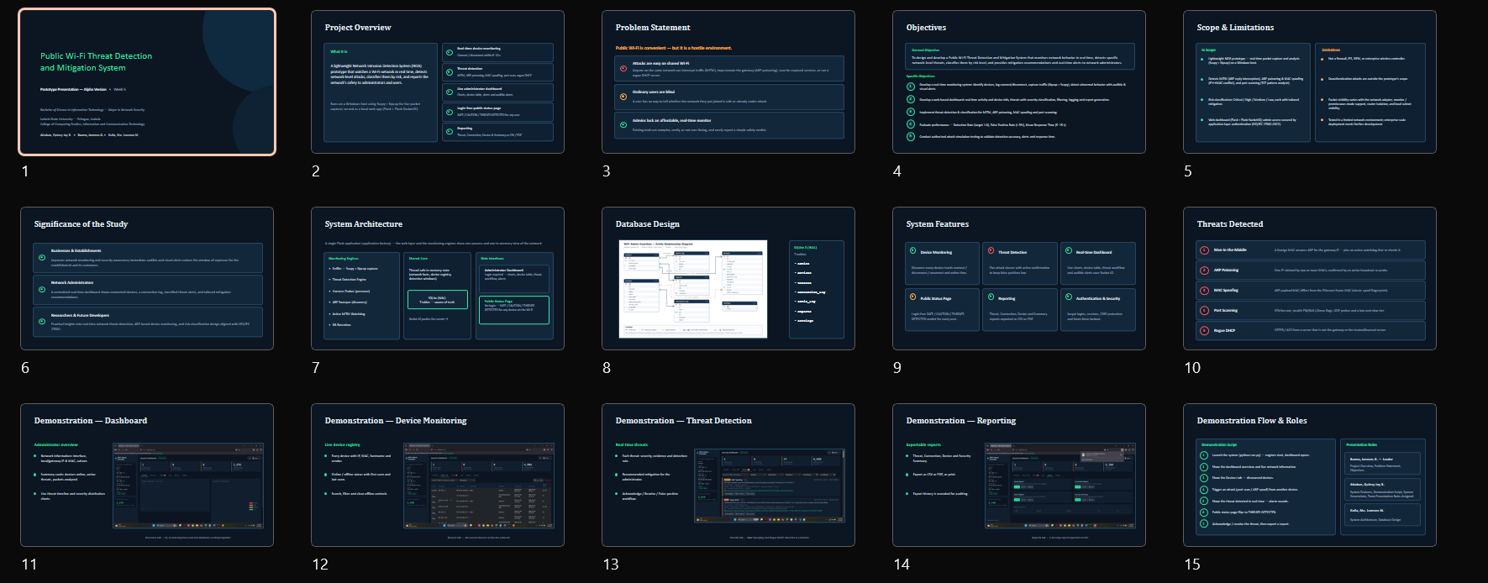
Demonstration Script
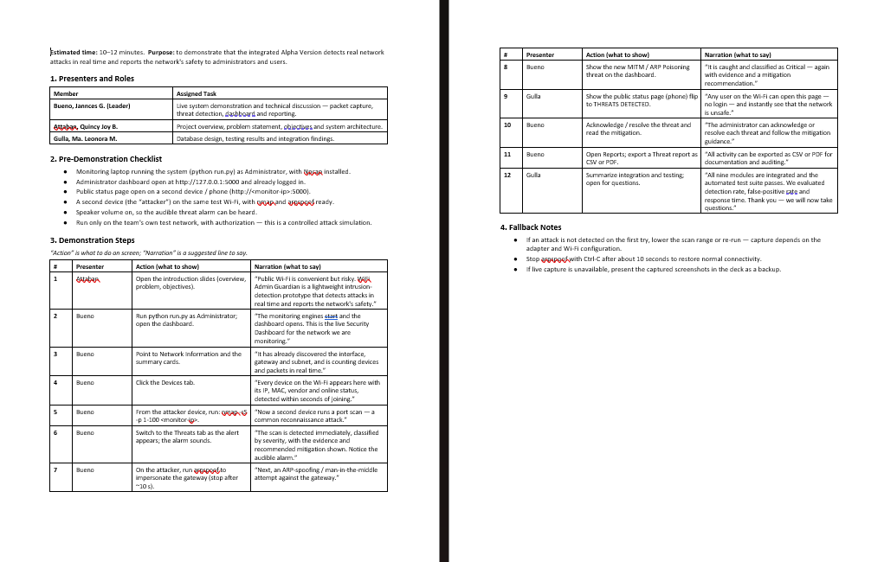
Prototype Screenshot
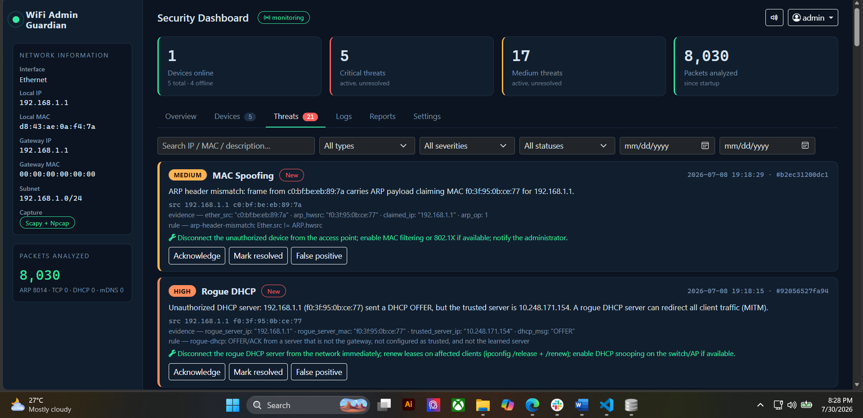
Prototype Screenshot
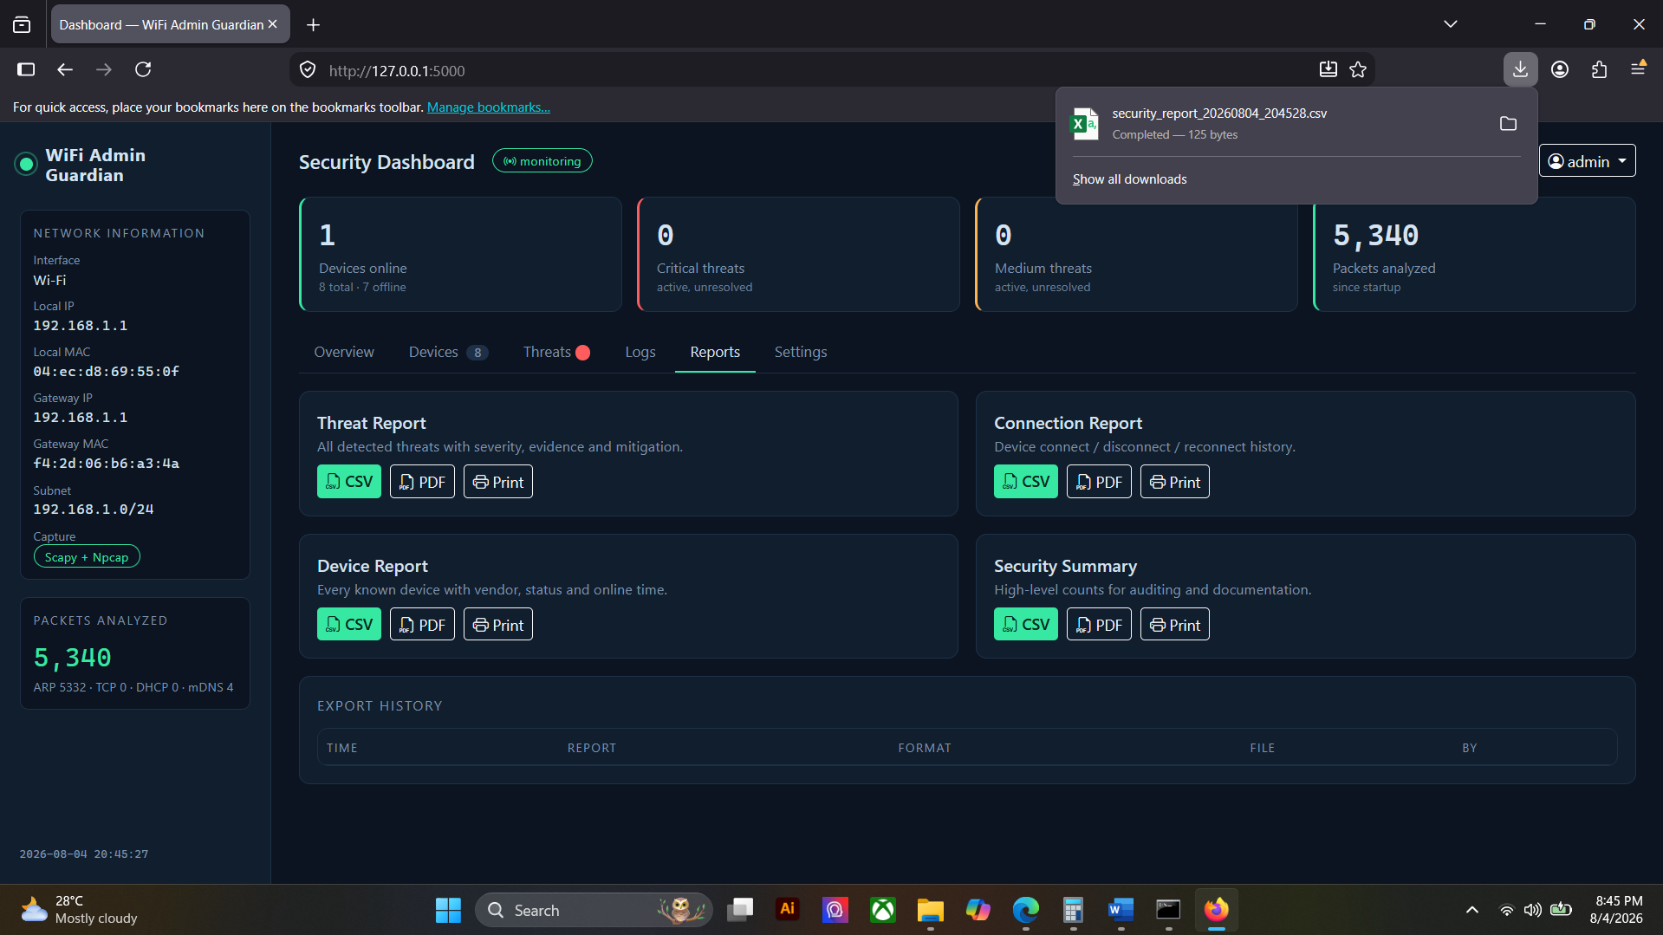

ACTIVITY 6
SYSTEM INTEGRATION REPORT

Purpose
To document integration activities and Alpha Version development.
Procedure
- Summarize completed integration activities.
- Document modules integrated.
- Record testing activities.
- Identify remaining enhancements.
- Complete Form 6.

FORM 6
SYSTEM INTEGRATION REPORT

Project Information
Project Title: Public Wi-Fi Threat Detection and Mitigation System
Date Submitted: August 21, 2026
Integrated Modules
Module | Status
Database Module (SQLite, 7 tables) | Integrated
Authentication Module | Integrated
Packet Capture Module (Scapy + Npcap) | Integrated
Device Registry and Liveness Prober | Integrated
Threat Detection Engine | Integrated
Notification Module (Socket.IO alerts) | Integrated
Administrator Dashboard (user interface) | Integrated
Public Status Page | Integrated
Reporting Module | Integrated

Integration Summary
The nine modules developed during Weeks 3 and 4 were combined into a single working application following the integration sequence in Form 1, starting from the database layer and ending with the reporting module. The database was integrated first because every other module depends on it, followed by authentication, then the capture and detection chain, and finally the interfaces that present the results. Communication between layers was verified at each step: the interface talks to the application layer through a REST API, live events are pushed to the browser over Socket.IO, and all modules share one thread-safe SQLite connection layer with serialised writes. No module needed to be rewritten during integration.
Preliminary Testing Summary
Five major functionalities were executed end to end — login, device registration, threat processing, record retrieval and report generation — and all five passed. Four verification items were confirmed: data flow, module communication, database transactions and user access. The automated suite of 51 tests was run against the integrated build and continued to pass, covering detection accuracy, access control and the database layer. Four issues were recorded in Form 3, all carried over from Week 4: two detection false positives rated Medium and two display defects rated Low. No critical errors occurred during testing and the system ran without stopping for the duration of the checks.
Enhancements Planned Before Week 6
• Complete the two-detection false-positive corrections together with their paired regression tests, so that suppressing a false alarm cannot weaken genuine detection.
• Apply the two display corrections: numeric ordering of IP addresses in the device list, and a monitoring switch that reflects the live state.
• Add date-range and severity filtering to the reporting module before export.
• Conduct controlled attack simulations to measure detection rate, false-positive rate and mean response time.
• Produce the prototype presentation slides and demonstration script listed in Form 5.

Prepared by: | Reviewed by:
Bueno, Jannces G. | Romero Dante C. Salum, DIT
Group Leader | Project Adviser

